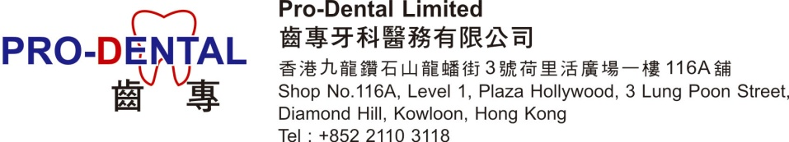

[此牙科保健計劃只供以下合資格人士，閣下如非此類人士，請勿閱覽此資料。] (This dental plan is only for the following eligible persons. If you are not one of them, please do not read the information herewith)

香港中文大學校友及家屬 牙科優惠計劃
CUHK Alumni & Families Dental Plan

$280洗牙石及牙漬包口腔檢查及以下優惠
$280 Scaling & Polishing including free Oral Check-up & Privileges below
(使用期: 即日起至31/8/2020 Valid period: Now till 31/8/2020) *

優惠項目 Privileges*

- 牙科診症 Dental Consultation 免費Free 無限次Unlimited
- X-光細片 (如有需要) Intra-Oral X-Ray (if necessary) 免費Free 無限次Unlimited
- 氟素治療 (如有需要) Fluoride Varnish Treatment (if necessary) 免費Free 無限次Unlimited
- 補牙 代用現金 Fillings Cash Credits 每隻牙齒 減 deduct $200 /Tooth
- 脫牙 代用現金 Extraction Cash Credits 每隻牙齒 減deduct $200 /Tooth
- 根管治療 代用現金 Root Canal Treatment Cash Credits 每隻牙齒 減 deduct $500 /Tooth
- 牙套/牙橋 代用現金 Crown/Bridge Cash Credits 每副 減 deduct $1,000 /Set
- 活動假牙 代用現金 Denture Cash Credits 每副 減 deduct $1,000 /Set
- 種牙 代用現金 Implant Cash Credits 每隻 減 deduct $2,000 /Tooth
- 漂牙 代用現金 Whitening Cash Credits 每療程減 deduct $1,000 /Treatment
- 緊急治療 Emergency Treatment 免費Free 無限次Unlimited
- 臨時止痛 - Temporary Pain Relief
- 臨時補牙 / 敷料 - Temporary Filling / Dressing
- 牙瘡 (非手術性放膿) - Abscess (Drainage Without Surgery)
- 以上治療項目所需藥物 Medication for the above treatments 免費Free 無限次Unlimited
- 額外洗牙石及牙漬 Extra Scaling & Polishing $ 200 一次Once

* 於計劃使用期內享用，逾期無效。公司保留解釋、使用及更改權利
* To be enjoyed within Valid Period only. Company reserves right of interpretation, availability and amendment.

診所開放時間：星期一至六上午十時至下午八時，星期日敬請預約。
Clinic opening hours are Mon-Sat: 10am -8 pm, Sun: on appointment basis.

任何查詢請致電 21103118.
Please call tel.: 2110 3118 for enquiries

See Application Form on the following page
申請表格見下頁

申請表格 Application Form

中文姓名  Chinese Name | 英文姓名  English Name | 性別  Gender | 身份證  HKID | 電話  Tel | 身份  Status | 入學年份  Enrolled Year | 費用Fee
 |  |  |  |  | 口校友口Alumni |  | HK$280
 |  |  |  |  | 口家屬口Families |  | HK$280
 |  |  |  |  | 口家屬口Families |  | HK$280
 |  |  |  |  | 口家屬口Families |  | HK$280
 |  |  |  |  | 口家屬口Families |  | HK$280
 |  |  |  |  | 口家屬口Families |  | HK$280
 |  |  |  |  | 口家屬口Families |  | HK$280

注意: 所有治療必須在有效使用期內享用, 所有收取費用不予發還。
Note: All treatments shall fall within Valid Period. Fee paid is non-refundable.

申請人簽名Applicant’s Signature: ___________________ 日期Date: ________________

總費用 Total Fee: HK$____________

申請表格及費用可於求診時在本醫務中心填寫及支付。請致電 2110 3118 預約，並註明中大校友及家屬身份。求診時請出示有效的相關證明，如中大校友信用卡、中大校友圖書證、載有中大校友收件人姓名的「中大校友電子月報」電郵等。閣下亦可預先填妥申請表格及將費用存入「東亞銀行」帳戶號碼015-146-68-00157-1 「齒專牙科醫務有限公司」。然後將 申請表格 及 銀行存款單 Whatsapp或 Wechat至 57024813。
診所開放時間：星期一至六上午十時至下午八時，星期日敬請預約。

You can complete the form and make payment when visiting the clinic. Please call 21103118 to make appointment and state CUHK alumni & families status. Please present the relevant identification proof (e.g. CUHK Alumni Credit Card, CUHK Alumni Library Card, email copy of the alumni e-newsletter ‘Alumni Matters’containing the name of the alumni recipient etc) upon arrival. Alternatively, you may complete the form and deposit the fee to “Pro-Dental Limited”, Bank of East Asia Ltd. Account Number 015-146-68-00157-1, and then Whatsapp or Wechat the application form and deposit slip to 57024813.
Clinic opening hours are Mon-Sat: 10am -8 pm, Sun: on appointment basis.

For Office Use:

Received by ________________________ Date _________________ Payment Confirmed $_____________

Patient Record Created on _____________ Alert Marked __________ Confirmation Sent ______________

